Everlytic Developer Assessment

Name: **Swelihle Mkhwanazi**

Email: [**skmkhwanazi5@gmail.com**](mailto:skmkhwanazi5@gmail.com)

**Stack:**

* Laravel 5.5
* PHP 7
* MySQL

**Setup:**

* Create database participants on MySql
* run composer update on terminal
* on .env file your connection should look like this:

DB_CONNECTION=mysql

DB_HOST=127.0.0.1

DB_PORT=3306

DB_DATABASE=participants

DB_USERNAME=root

DB_PASSWORD=

* run php artisan migrate
* run php artisan db:seed
* run php artisan serve

**Route:** [**http://127.0.0.1:8000/users**](http://127.0.0.1:8000/users)

**Your Application should look like:**

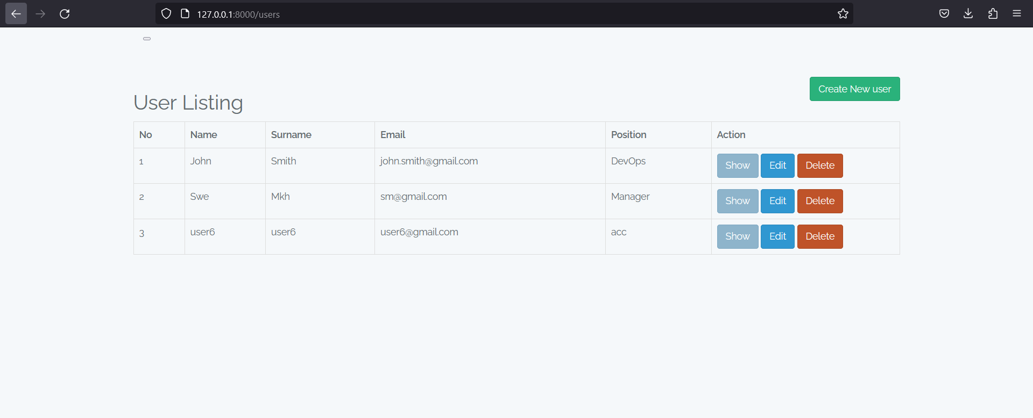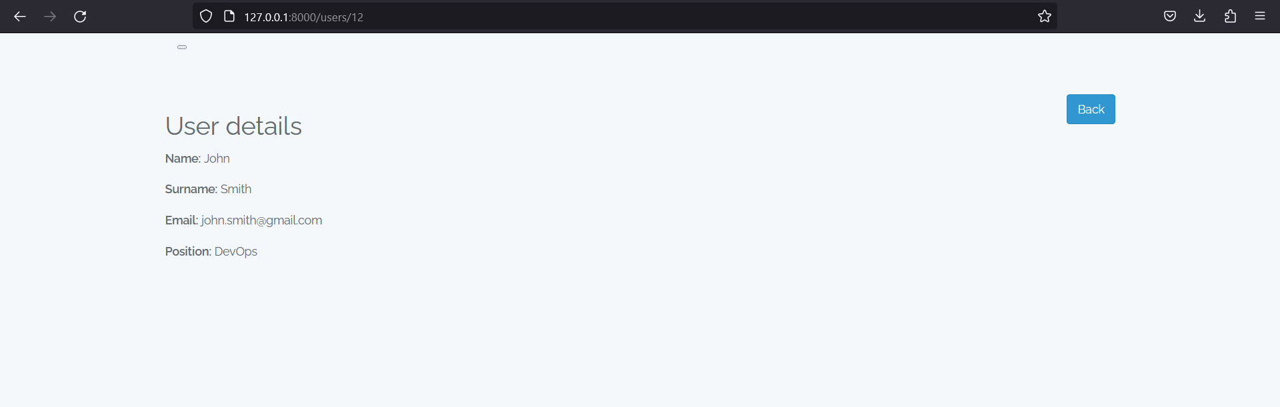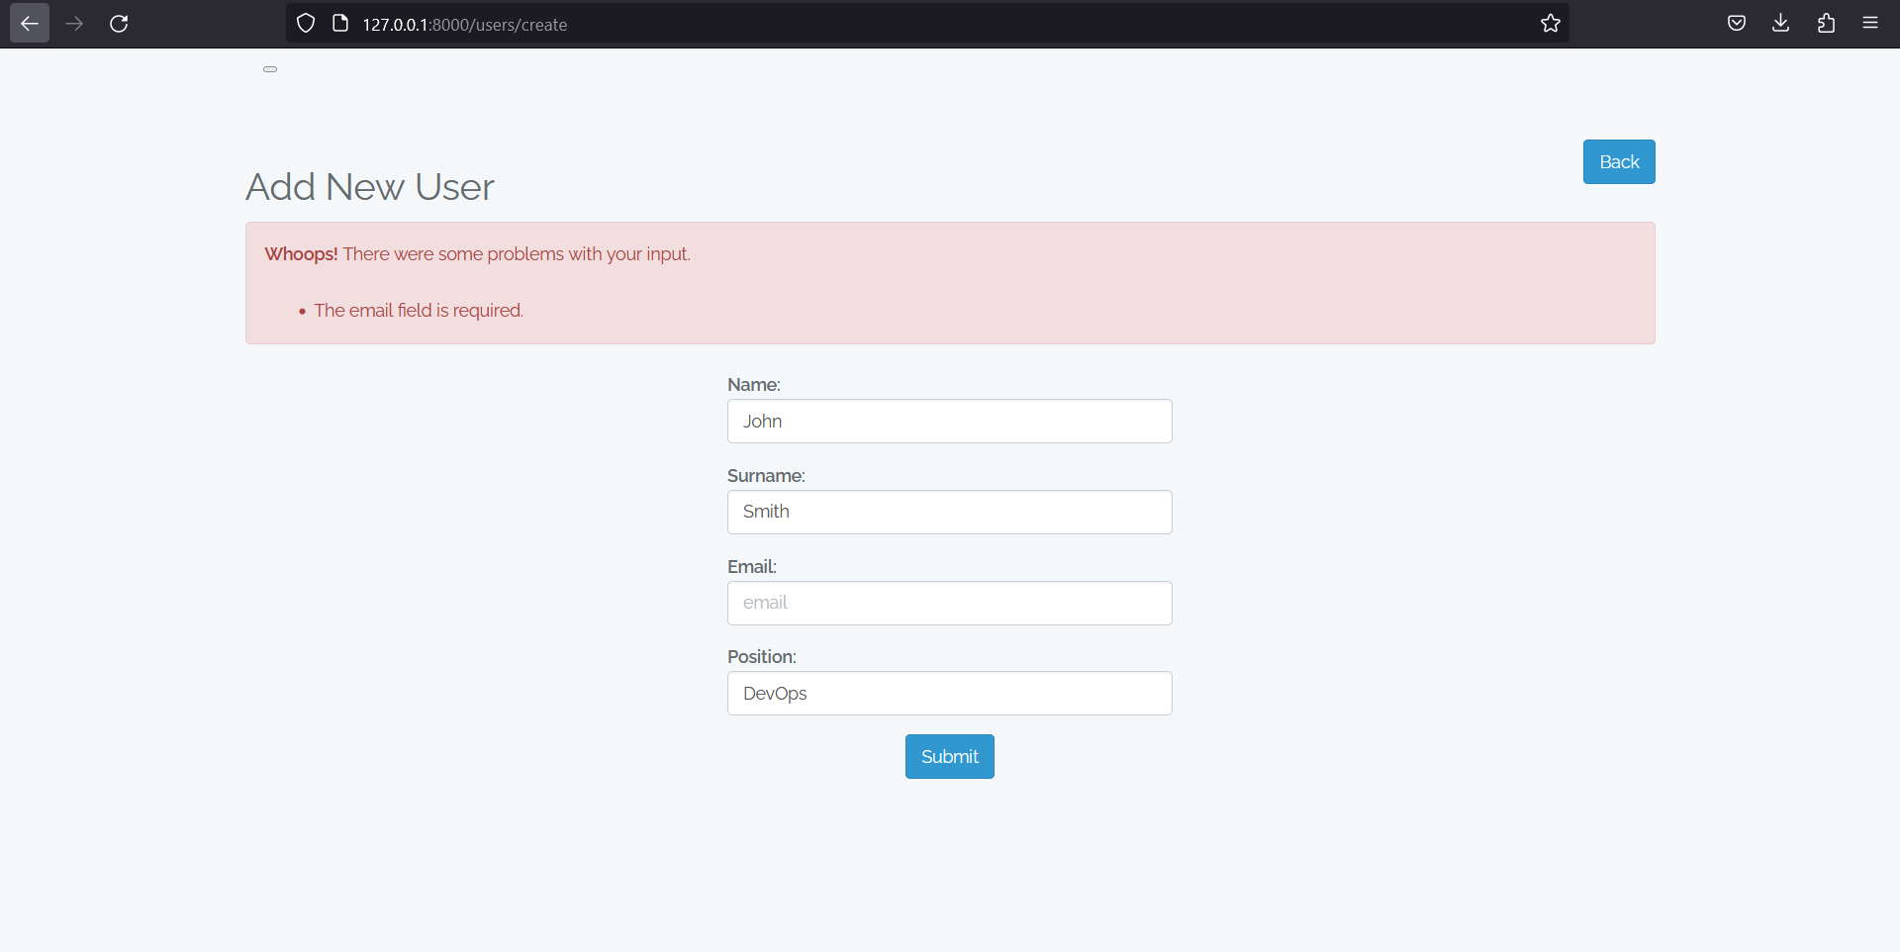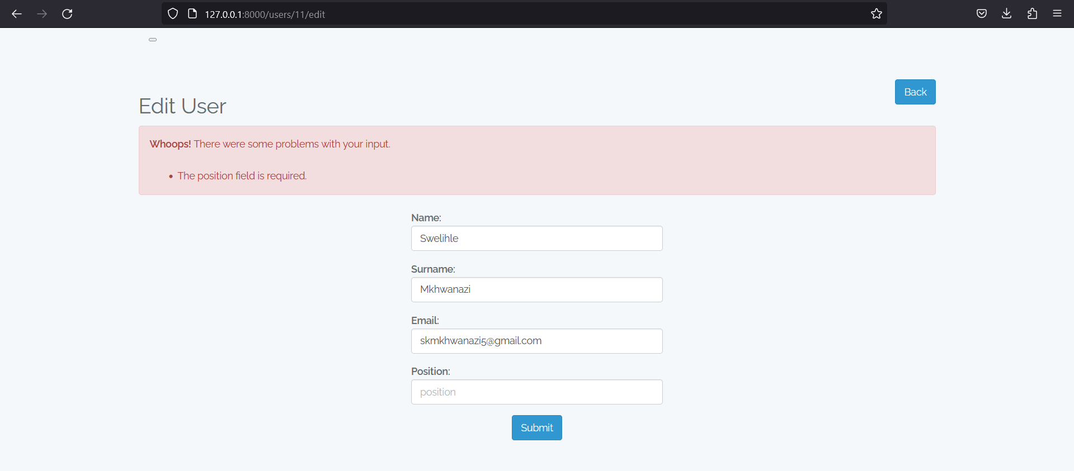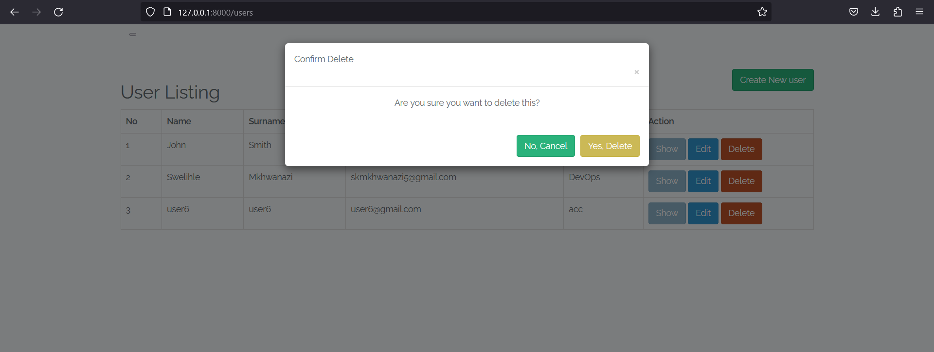

**Routes**

**Php artisan route:list**

